import os

import numpy as np

import pandas as pd

from scipy.stats import skew, kurtosis

from sklearn.datasets import load_diabetes

from sklearn.linear_model import LinearRegression, LogisticRegression

from sklearn.model_selection import train_test_split

from sklearn.preprocessing import StandardScaler

from sklearn.metrics import r2_score, mean_squared_error, accuracy_score, roc_auc_score, confusion_matrix, classification_report

import statsmodels.api as sm

uci = load_diabetes()

df_uci = pd.DataFrame(uci.data, columns=uci.feature_names)

df_uci["target"] = uci.target

pima_path = "diabetes.csv"

if not os.path.exists(pima_path):

raise FileNotFoundError("Please place 'diabetes.csv' in the same folder as this script.")

df_pima = pd.read_csv(pima_path)

if "Outcome" not in df_pima.columns:

df_pima.rename(columns={df_pima.columns[-1]: "Outcome"}, inplace=True)

def univariate_analysis(df, name):

print(f"\n===== Univariate Analysis: {name} =====")

results = []

for col in df.select_dtypes(include=[np.number]).columns:

data = df[col].dropna()

results.append({

"Feature": col,

"Count": len(data),

"Mean": data.mean(),

"Median": data.median(),

"Mode": data.mode().iloc[0] if not data.mode().empty else np.nan,

"Variance": data.var(),

"Std Dev": data.std(),

"Skewness": skew(data),

"Kurtosis": kurtosis(data)

})

return pd.DataFrame(results)

uni_uci = univariate_analysis(df_uci, "UCI Diabetes")

uni_pima = univariate_analysis(df_pima, "Pima Indians Diabetes")

print("\n===== Bivariate Analysis: UCI Diabetes (Linear Regression) =====")

X = df_uci[["bmi"]] # using 'bmi' as strongest predictor

y = df_uci["target"]

X_train, X_test, y_train, y_test = train_test_split(X, y, test_size=0.2, random_state=42)

lin_reg = LinearRegression().fit(X_train, y_train)

y_pred = lin_reg.predict(X_test)

print(f"R²: {r2_score(y_test, y_pred):.3f}")

print(f"RMSE: {np.sqrt(mean_squared_error(y_test, y_pred)):.3f}")

print("\n===== Bivariate Analysis: Pima (Logistic Regression) =====")

X_pima = df_pima[["Glucose"]] # using Glucose as single predictor

y_pima = df_pima["Outcome"]

Xp_train, Xp_test, yp_train, yp_test = train_test_split(X_pima, y_pima, test_size=0.2, random_state=42, stratify=y_pima)

log_reg = LogisticRegression(max_iter=1000).fit(Xp_train, yp_train)

yp_pred = log_reg.predict(Xp_test)

yp_prob = log_reg.predict_proba(Xp_test)[:, 1]

print(f"Accuracy: {accuracy_score(yp_test, yp_pred):.3f}")

print(f"AUC: {roc_auc_score(yp_test, yp_prob):.3f}")

print("\n===== Multiple Regression: UCI Diabetes =====")

X_all = sm.add_constant(df_uci.drop(columns=["target"]))

model = sm.OLS(df_uci["target"], X_all).fit()

print(model.summary())

print("\n===== Multiple Logistic Regression: Pima =====")

X_pima_all = df_pima.drop(columns=["Outcome"])

scaler = StandardScaler()

X_scaled = scaler.fit_transform(X_pima_all)

Xp_train, Xp_test, yp_train, yp_test = train_test_split(X_scaled, y_pima, test_size=0.2, random_state=42, stratify=y_pima)

log_reg_full = LogisticRegression(max_iter=2000).fit(Xp_train, yp_train)

yp_pred_full = log_reg_full.predict(Xp_test)

yp_prob_full = log_reg_full.predict_proba(Xp_test)[:, 1]

print(f"Accuracy: {accuracy_score(yp_test, yp_pred_full):.3f}")

print(f"AUC: {roc_auc_score(yp_test, yp_prob_full):.3f}")

print(confusion_matrix(yp_test, yp_pred_full))

print(classification_report(yp_test, yp_pred_full))

print("\n===== COMPARISON =====")

print(f"UCI R² (Multiple Regression): {model.rsquared:.3f}")

print(f"Pima Accuracy (Multiple Logistic): {accuracy_score(yp_test, yp_pred_full):.3f}, AUC: {roc_auc_score(yp_test, yp_prob_full):.3f}")

Output:-

===== Bivariate Analysis: UCI Diabetes (Linear Regression) =====

R²: 0.233

RMSE: 63.732

===== Bivariate Analysis: Pima (Logistic Regression) =====

Accuracy: 0.708

AUC: 0.767

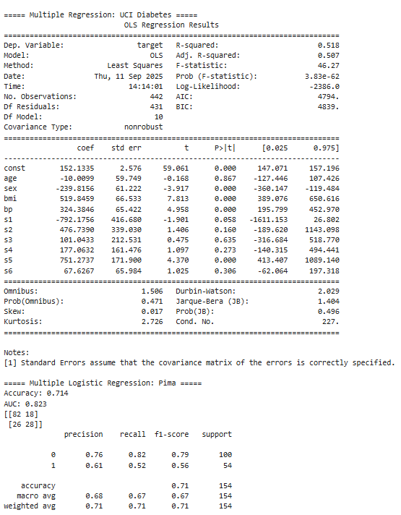

===== COMPARISON =====

UCI R² (Multiple Regression): 0.518

Pima Accuracy (Multiple Logistic): 0.714, AUC: 0.823